Assignment 1: Installation of CentOS on Virtual Machine

Solution: My laptop runs on Ubuntu 16.04, so i did the following steps to Install Cent OS.

Step1: downloaded Cent OS ISO file from centos.org (The ISO file shown in the screenshot)

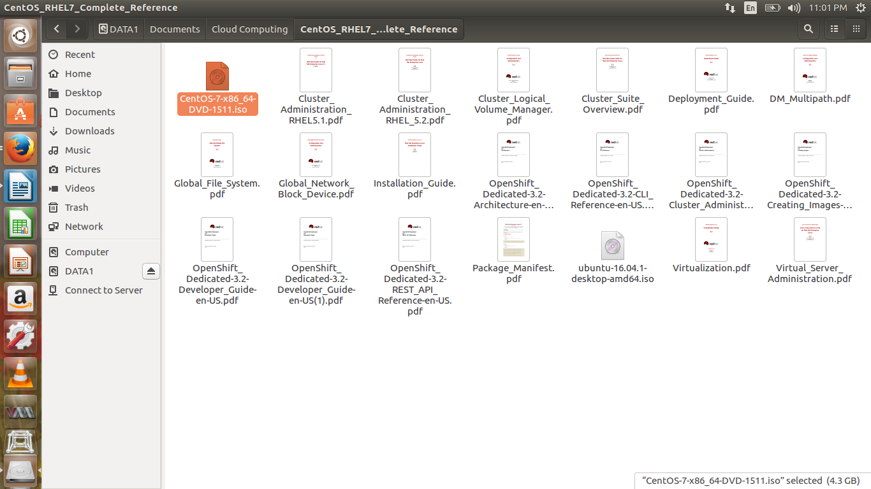

Step2: Installed Boxes ( VM Ware player equivalent in Ubuntu ) from Ubuntu software centre.

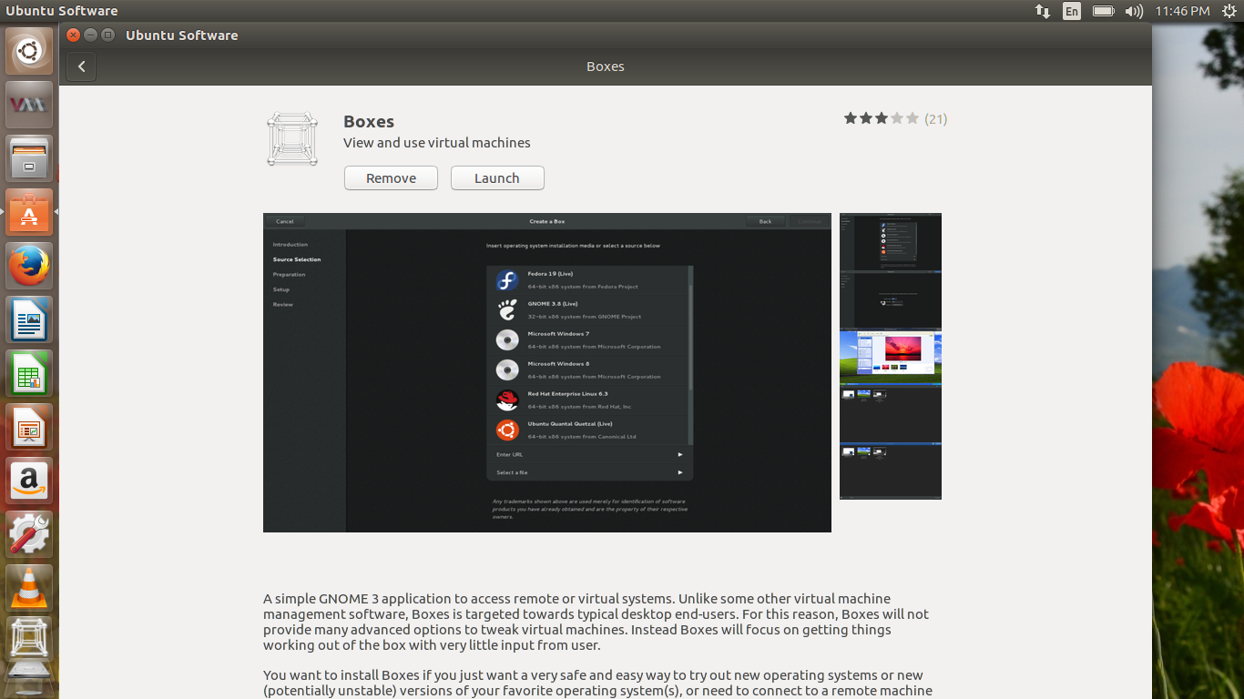

Step3 : open the boxes from launch bar on left, click on “New” machine. Select the ISO file from the local drive / folder and follow the installation instructions.

The below screen shot shows the Cent OS on Boxes Virtual Machine.

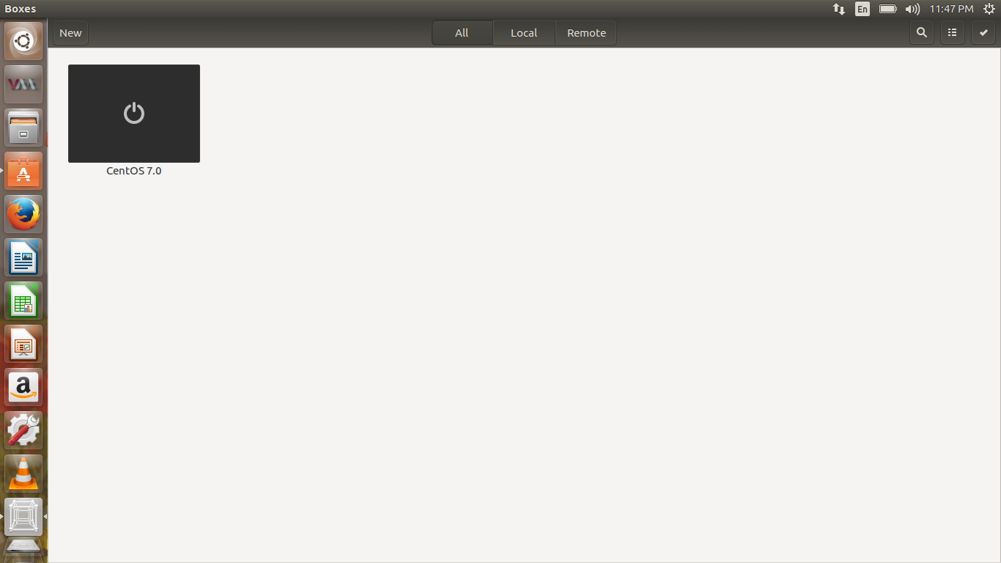

Cent OS customisation:

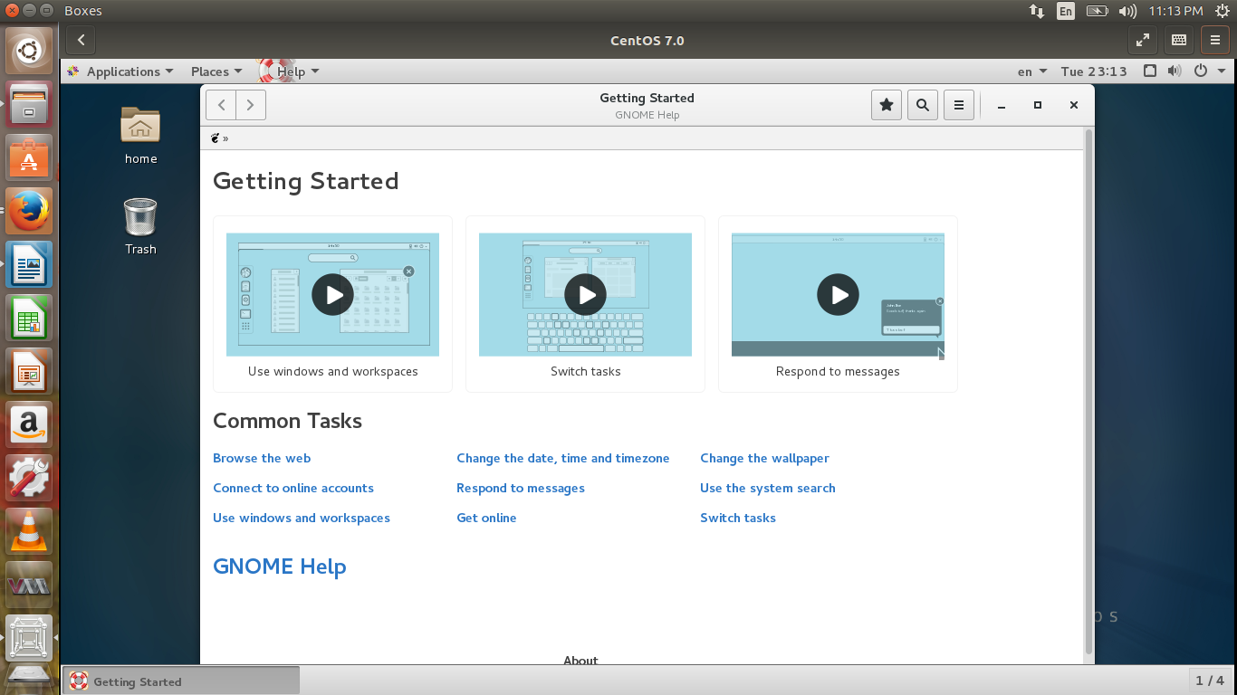

Thus, Cent OS successfully installed on a Virtual Machine Manager ( Boxes in this case ) in Ubuntu environment, the network configuration and other settings done .